## Module 2 Student Questions

## Spin Quantum Number - Application Questions

1. How many different allowed spin states does a spin-2 particle have? What are the *ms* values for these states?
2. How many different allowed spin states does a spin-3/2 particle have? What are the *ms* values for these states?
3. Quantum particles that behave effectively as spin-zero particles (*s = 0*) are sometimes said to occupy a singlet state and spin-1 particles (*s = 1*) are sometimes said to occupy a triplet state. What do you think the reasoning is behind those names?
4. Given the observations made in the Stern-Gerlach experiment shown above, what would be the effective spin quantum number *s* of the neutral silver atoms? How did you come to that conclusion?

## Potential Sources For Magnetic Resonance - Guided Inquiry Questions

1. Use the Pauli exclusion principle, Aufbau principle, and Hund’s rule to give the electron configuration of the six electrons of a carbon atom in its lowest energy atomic state.
2. Protons and neutrons are each made up of three quarks which each carry spin-1/2. Use the information provided above about finding the total spin of multiple spin-1/2 particles to explain why the three spin-1/2 quarks add together to give a total spin of 1/2 for both protons and neutrons.

## Nuclear Spin - Guided Inquiry Questions

*Use the tables shown below along with this* [*PhET simulation*](https://phet.colorado.edu/sims/html/isotopes-and-atomic-mass/latest/isotopes-and-atomic-mass_en.html) *to answer the questions in this section.*

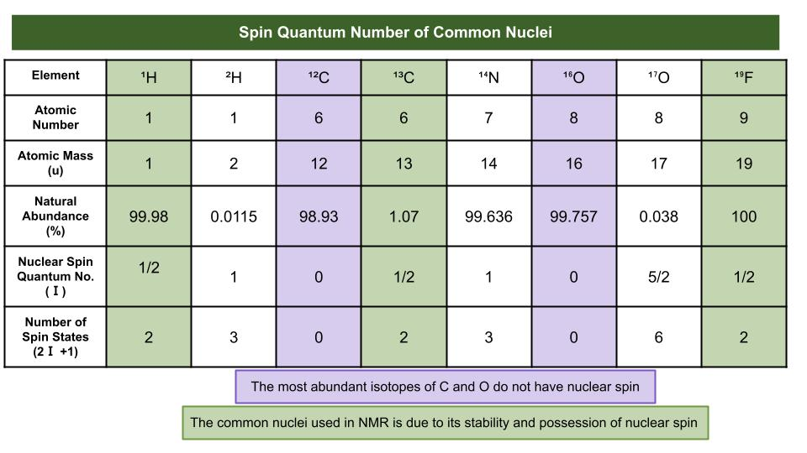

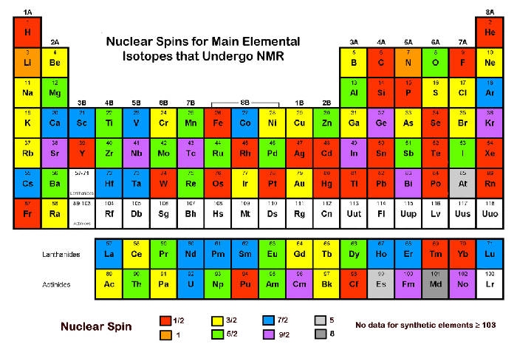

1. Using the simulation to check out different isotopes of the same element, what appears to cause a nucleus to become unstable? Why do you think it is important to use stable nuclei for magnetic resonance experiments?
2. By far the most common nucleus used for NMR is that of hydrogen-1 (essentially a single proton). What are the advantages of choosing to use this particular isotope of hydrogen?
3. Why is carbon-12 *not* a good choice for NMR, despite its large natural abundance? Which spin-1/2 carbon isotope do you think is then referenced in the periodic table above? *Hint: we want the isotope to be stable as well!*
4. Which spin-1/2 fluorine isotope do you think is referenced in the periodic table above? *Hint: look at different isotopes of fluorine and determine the nuclear spin using the rules above.* What are the advantages to choosing this particular isotope?

## Reflection Questions

1. Why might learning more about quantum spins be considered important?
2. Use what you learned about the Aufbau principle and the simplified explanation of how spin-1/2 particles get added together to provide some justification for the rules given above for finding the nuclear spin of an isotope. *Check out this YouTube video if you want a more thorough explanation of how nuclear spin gets calculated:* [*https://www.youtube.com/watch?v=pcyfvwnHddA*](https://www.youtube.com/watch?v=pcyfvwnHddA)
3. For each of the following nuclear isotopes, provide your assessment of whether they may be useful for NMR or not. (Look for non-zero nuclear spin, stability, relative abundance, etc.)
   1. Phosphorus-31 (31P)
   2. Carbon-15 (15C)
   3. Helium-3 (3He)
   4. Silicon-29 (29Si)

**Follow this rubric to assess your work for this module:**

| **Learning Outcome** | **Adequate** | **Needs improvement** | **Inadequate** | **Missing** |
| --- | --- | --- | --- | --- |
| **Is able to calculate the number of spin states and the possible *ms* values for a given spin quantum number, *s*** | Can easily calculate the number of spins states and possible *ms* values without referencing the text. | Can easily calculate the number of spins states and possible *ms* values if referencing the text. | Struggles to calculate the number of spin states and possible *ms* values. | Does not demonstrate any understanding of what is meant by spin states and *ms* values. |
| **Is able to determine whether a nuclear spin will be zero, integer, or half- integer** | Can easily determine whether a nuclear spin will be zero, integer, or half- integer without referencing the text. | Can easily determine whether a nuclear spin will be zero, integer, or half- integer if referencing the text. | Struggles to determine whether a nuclear spin will be zero, integer, or half- integer. | Does not demonstrate any understanding of what is meant by nuclear spin being zero, integer, or half- integer |
| **Is able to identify and explain the reasons certain isotopes are most useful for NMR** | Can accurately describe at least 3 reasons certain isotopes are most useful for NMR. | Can accurately describe at least 2 reasons certain isotopes are most useful for NMR. | Can roughly describe at least 1 reason certain isotopes are most useful for NMR. | Cannot accurately describe any reasons certain isotopes are most useful for NMR. |